Relationships between objects
- association – one object points to another, but they are independent, each has its own scope.
Using relationship
- aggregation – like association, but there is only 1 pointer, still each has the its own scope
using relationship with parent

- composition – one object will create and destroy another objects

// TO DO
read more a give acomplete list

composition quiz
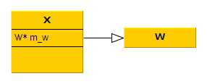

class X
{
public:
X():m_w(new W) {}
~X()
{
delete m_w;
}

X& X(const X& other_);
X& operator=(const X& other_);
private:
W* m_w;
}

X& X::operator=(const X& other_)
{
if(this != &other)
{
delete m_w;
m_w = new W(*other.m_w); // cctor of the W class
}

// or
*m_w = *other_.m_w; // use directly the cctor of the w class.
}

class W // copyable, meaning, has cctor and operator=

